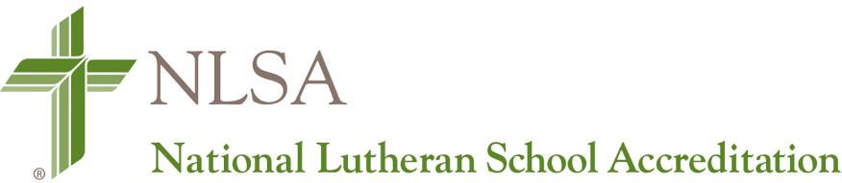

Request for Appointment of Validation Team Members

To Be Completed by the School Administrator
As soon as all Validation Team members are recruited, please complete this form electronically and email it to your LCMS District Education Executive for his/her review. This form must be accompanied by all completed NLSA Conflict of Interest forms for each individual Validation Team member. All Validation Team members must be approved by the district and appointed by the NLSA Executive Director no later than 30 days prior to the visit.

School Name:
School Address:
LCMS District:
Administrator Name(s):
Accreditation Protocol:
Partner Agency Accreditation:
Validation Team Visit Date:

Requested Validation Team Members
Team Member Name  (Captain Listed First) | Validation Team Position | Current School  (Name, City, State) | Indicate “Public”, “Lutheran” or “Other Christian”
Instructions for LCMS District Offices:
Upon review and approval of this form by the District Education Executive, it is to be submitted along with all Conflict of Interest documentation to Kristin Freeman (Kristin.Freeman@lcms.org) in the LCMS School Ministry Office. All documentation for the approval of a Validation Team (Request for Appointment of Validation Team Members and NLSA Conflict of Interest forms) are to be sent as a single email to avoid delays in approval or confusion with other NLSA documentation.

